**Coding Examples**

**o PDF of Binomial Distribution**

# Parameters

n <- 10 # Number of trials

p <- 0.5 # Probability of success

# Values of x

x <- 0:n

# PDF

pdf_values <- dbinom(x, size = n, prob = p)

# Print PDF values

print(pdf_values)

output:

n <- 10

> p <- 0.5

> x <- 0:n

> pdf_values <- dbinom(x, size = n, prob = p)

> print(pdf_values)

[1] 0.0009765625 0.0097656250 0.0439453125 0.1171875000 0.2050781250 0.2460937500 0.2050781250 0.1171875000 0.0439453125

[10] 0.0097656250 0.0009765625

**o CDF of Binomial Distribution**

# CDF

cdf_values <- pbinom(x, size = n, prob = p)

# Print CDF values

print(cdf_values)

output:

cdf_values <- pbinom(x, size = n, prob = p)

> print(cdf_values)

[1] 0.0009765625 0.0107421875 0.0546875000 0.1718750000 0.3769531250 0.6230468750 0.8281250000 0.9453125000 0.9892578125

[10] 0.9990234375 1.0000000000

**o Visualizing PDF and CDF**

library(ggplot2)

# Data frame for plotting

data <- data.frame(x = x, PDF = pdf_values, CDF = cdf_values)

# Plot PDF

ggplot(data, aes(x = x, y = PDF)) +geom_bar(stat = "identity", fill = "skyblue") +ggtitle("PDF of Binomial Distribution") +

xlab("Number of Successes") + ylab("Probability")

# Plot CDF

ggplot(data, aes(x = x, y = CDF)) +geom_line(color = "blue") +geom_point(color = "blue") +ggtitle("CDF of Binomial Distribution") +

xlab("Number of Successes") + ylab("Cumulative Probability")

output:

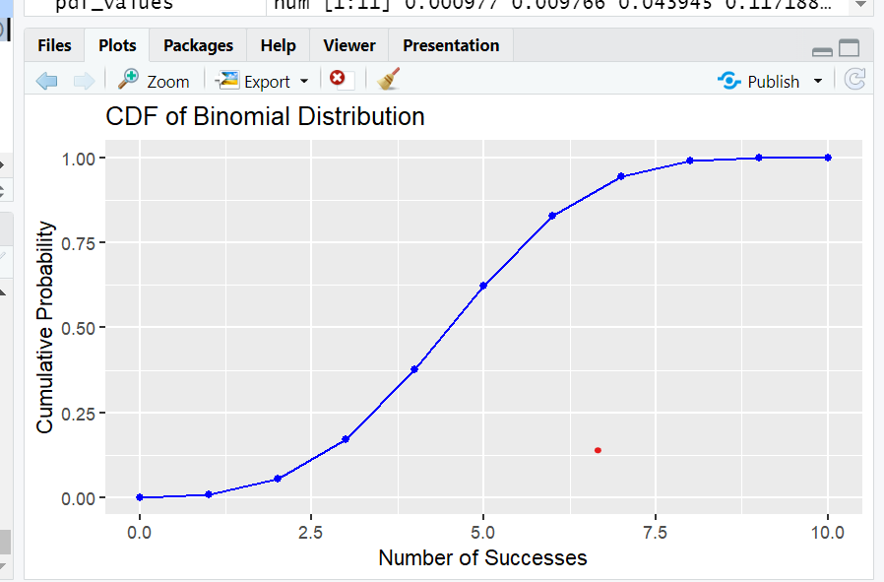

**Exercises**

1. Exercise 1: Visualize the PDF for Different Parameters

o Task: Plot the PDF of a binomial distribution with n=15n = 15n=15 and p=0.4p =

0.4p=0.4.

o Expected Output:

# Parameters

n <- 15

p <- 0.4

# Values of x

x <- 0:n

# PDF

pdf_values <- dbinom(x, size = n, prob = p)

# Data frame for plotting

data <- data.frame(x = x, PDF = pdf_values)

# Plot PDF

ggplot(data, aes(x = x, y = PDF)) +

geom_bar(stat = "identity", fill = "lightgreen") +

ggtitle("PDF of Binomial Distribution (n=15, p=0.4)") +

xlab("Number of Successes") + ylab("Probability")

output:

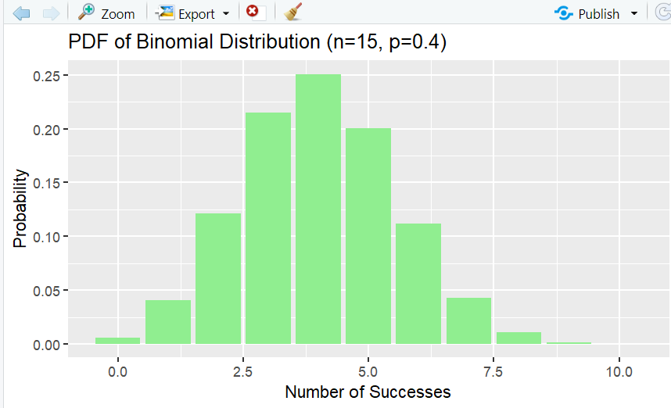

2. Exercise 2: Visualize the CDF for Different Parameters

o Task: Plot the CDF of a binomial distribution with n=20n = 20n=20 and p=0.7p =

0.7p=0.7.

o Expected Output:

# Parameters

n <- 20

p <- 0.7

# Values of x

x <- 0:n

# CDF

cdf_values <- pbinom(x, size = n, prob = p)

# Data frame for plotting

data <- data.frame(x = x, CDF = cdf_values)

# Plot CDF

ggplot(data, aes(x = x, y = CDF)) +

geom_line(color = "red") +

geom_point(color = "red") +

ggtitle("CDF of Binomial Distribution (n=20, p=0.7)") +

xlab("Number of Successes") + ylab("Cumulative Probability")

output:

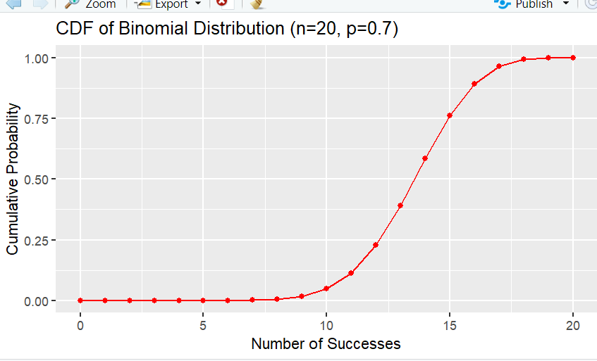

3. Exercise 3: Compare PDFs of Different Binomial Distributions

o Task: Plot the PDFs of binomial distributions with parameters n=10,p=0.3n = 10,

p = 0.3n=10,p=0.3 and n=10,p=0.6n = 10, p = 0.6n=10,p=0.6 on the same graph

for comparison.

o Expected Output:

# Parameters

n <- 10

p1 <- 0.3

p2 <- 0.6

# Values of x

x <- 0:n

# PDF

pdf_values_p1 <- dbinom(x, size = n, prob = p1)

pdf_values_p2 <- dbinom(x, size = n, prob = p2)

# Data frame for plotting

data <- data.frame(x = rep(x, 2),

PDF = c(pdf_values_p1, pdf_values_p2),

Probability = factor(rep(c("p=0.3", "p=0.6"), each = length(x))))

# Plot PDFs

ggplot(data, aes(x = x, y = PDF, fill = Probability)) +

geom_bar(stat = "identity", position = "dodge") +

ggtitle("PDFs of Binomial Distributions (n=10, p=0.3 and p=0.6)") +

xlab("Number of Successes") + ylab("Probability")

output:

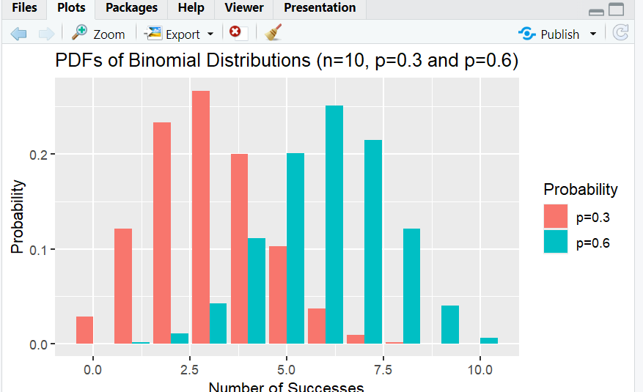

4. Exercise 4: Calculate and Plot the Probability of Success Ranges

o Task: Calculate the probability that the number of successes in a binomial

distribution with n=12n = 12n=12 and p=0.5p = 0.5p=0.5 falls between 4 and 8

inclusive. Plot the CDF and highlight the probability range.

o Expected Output:

# Parameters

n <- 12

p <- 0.5

# Values of x

x <- 0:n

# CDF

cdf_values <- pbinom(x, size = n, prob = p)

# Probability of successes between 4 and 8

prob_range <- pbinom(8, size = n, prob = p) - pbinom(3, size = n, prob = p)

print(prob_range) # Output should be the cumulative probability

# Data frame for plotting

data <- data.frame(x = x, CDF = cdf_values)

# Plot CDF and highlight the range

ggplot(data, aes(x = x, y = CDF)) +

geom_line(color = "blue") +

geom_point(color = "blue") +

ggtitle("CDF of Binomial Distribution (n=12, p=0.5) with Highlighted Range")

+

xlab("Number of Successes") + ylab("Cumulative Probability") +

geom_rect(aes(xmin = 4, xmax = 8, ymin = 0, ymax = 1), alpha = 0.2, fill =

"red")

Output:

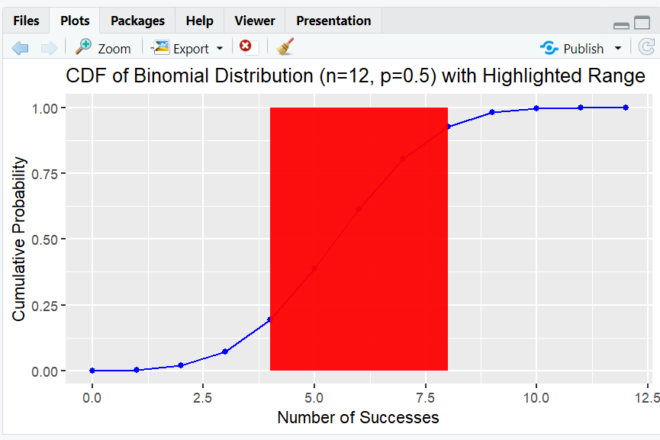

**Coding Examples**

**o PDF of Poisson Distribution**

# Install and load ggplot2 package

install.packages("ggplot2")

library(ggplot2)

# Parameter

lambda <- 4 # Average rate of occurrence

# Values of x

x <- 0:15

# PDF

pdf_values <- dpois(x, lambda)

# Print PDF values

print(pdf_values)

output:

[1] 1.831564e-02 7.326256e-02 1.465251e-01 1.953668e-01 1.953668e-01

[6] 1.562935e-01 1.041956e-01 5.954036e-02 2.977018e-02 1.323119e-02

[11] 5.292477e-03 1.924537e-03 6.415123e-04 1.973884e-04 5.639669e-05

[16] 1.503912e-05

**o CDF of Poisson Distribution**

# Parameter

lambda <- 4 # Average rate of occurrence

# Values of x

x <- 0:15

# CDF

cdf_values <- ppois(x, lambda)

# Print CDF values

print(cdf_values)

output:

[1] 0.01831564 0.09157819 0.23810331 0.43347012 0.62883694 0.78513039

[7] 0.88932602 0.94886638 0.97863657 0.99186776 0.99716023 0.99908477

[13] 0.99972628 0.99992367 0.99998007 0.99999511

**o Visualizing PDF and CDF**

# Data frame for plotting

data <- data.frame(x = x, PDF = pdf_values, CDF = cdf_values)

# Plot PDF

ggplot(data, aes(x = x, y = PDF)) +

geom_bar(stat = "identity", fill = "skyblue") +

ggtitle("PDF of Poisson Distribution (lambda=4)") +

xlab("Number of Events") + ylab("Probability")

# Plot CDF

ggplot(data, aes(x = x, y = CDF)) +

geom_line(color = "blue") +

geom_point(color = "blue") +

ggtitle("CDF of Poisson Distribution (lambda=4)") +

xlab("Number of Events") + ylab("Cumulative Probability")

output:

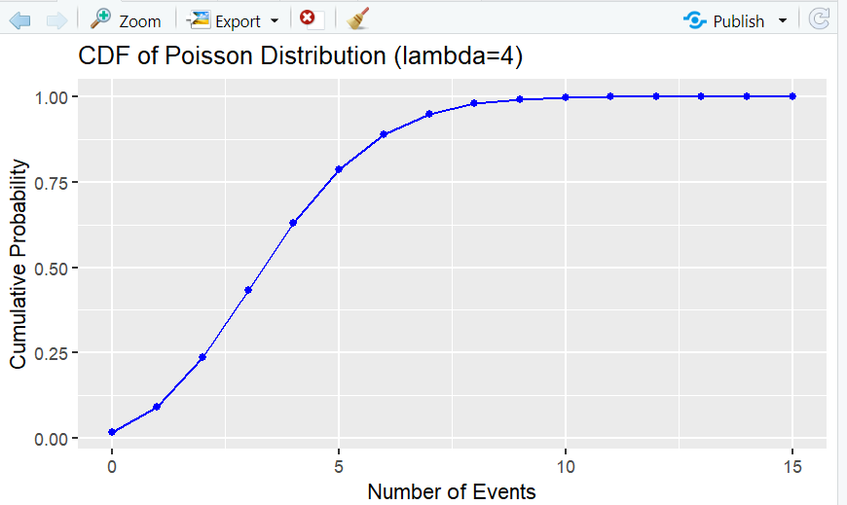

**Exercises**

1. Exercise 1: Visualize the PDF for Different Parameters

o Task: Plot the PDF of a Poisson distribution with λ = 6.

o Expected Output:

# Parameter

lambda <- 6 # Average rate of occurrence

# Values of x

x <- 0:15

# PDF

pdf_values <- dpois(x, lambda)

# Data frame for plotting

data <- data.frame(x = x, PDF = pdf_values)

# Plot PDF

ggplot(data, aes(x = x, y = PDF)) +

geom_bar(stat = "identity", fill = "lightgreen") +

ggtitle("PDF of Poisson Distribution (lambda=6)") +

xlab("Number of Events") + ylab("Probability")

output:

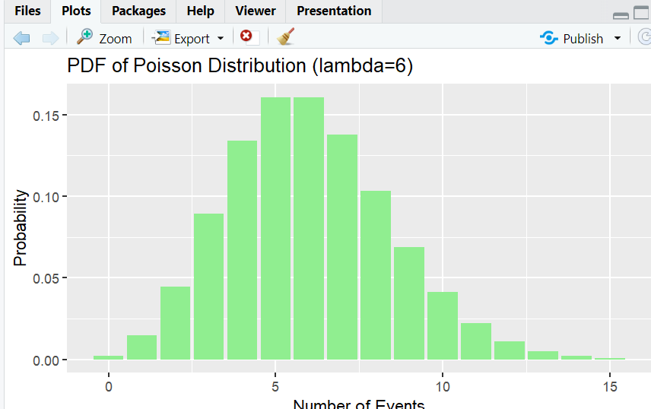

2. Exercise 2: Visualize the CDF for Different Parameters

o Task: Plot the CDF of a Poisson distribution with λ = 2.

o Expected Output:

# Parameter

lambda <- 2 # Average rate of occurrence

# Values of x

x <- 0:10

# CDF

cdf_values <- ppois(x, lambda)

# Data frame for plotting

data <- data.frame(x = x, CDF = cdf_values)

# Plot CDF

ggplot(data, aes(x = x, y = CDF)) +

geom_line(color = "blue") +

geom_point(color = "blue") +

ggtitle("CDF of Poisson Distribution (lambda=2)") +

xlab("Number of Events") + ylab("Cumulative Probability")

output:

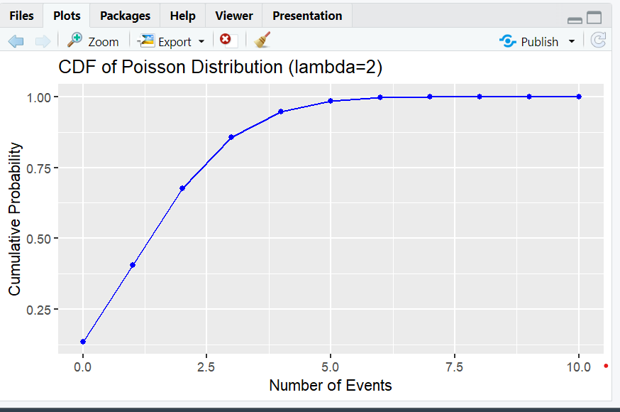

3. Exercise 3: Compare PDFs of Different Poisson Distributions

o Task: Plot the PDFs of Poisson distributions with parameters λ = 3 and λ = 7 on

the same graph for comparison.

o Expected Output:

# Parameters

lambda1 <- 3

lambda2 <- 7

# Values of x

x <- 0:15

# PDF

pdf_values_lambda1 <- dpois(x, lambda1)

pdf_values_lambda2 <- dpois(x, lambda2)

# Data frame for plotting

data <- data.frame(x = rep(x, 2),

PDF = c(pdf_values_lambda1, pdf_values_lambda2),

Lambda = factor(rep(c("lambda=3", "lambda=7"), each = length(x))))

# Plot PDFs

ggplot(data, aes(x = x, y = PDF, fill = Lambda)) +

geom_bar(stat = "identity", position = "dodge") +

ggtitle("PDFs of Poisson Distributions (lambda=3 and lambda=7)") +

xlab("Number of Events") + ylab("Probability")

output:

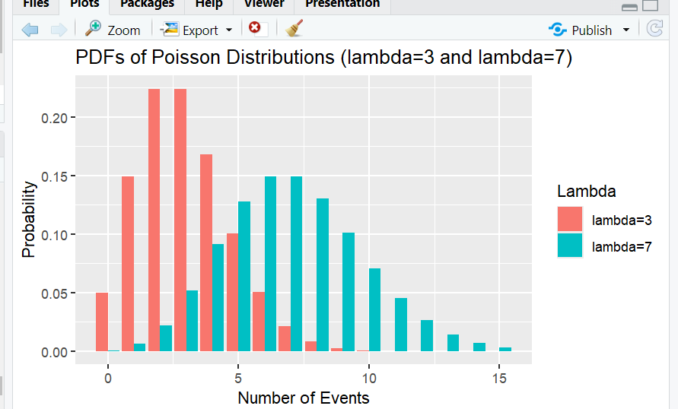

4. Exercise 4: Calculate and Plot the Probability of Event Ranges

o Task: Calculate the probability that the number of events in a Poisson distribution

with λ = 5 falls between 2 and 8 inclusive. Plot the CDF and highlight the

probability range.

o Expected Output:

# Parameter

lambda <- 5 # Average rate of occurrence

# Values of x

x <- 0:15

# CDF

cdf_values <- ppois(x, lambda)

# Probability of events between 2 and 8

prob_range <- ppois(8, lambda) - ppois(1, lambda)

print(prob_range) # Output should be the cumulative probability

# Data frame for plotting

data <- data.frame(x = x, CDF = cdf_values)

# Plot CDF and highlight the range

ggplot(data, aes(x = x, y = CDF)) +

geom_line(color = "blue") +

geom_point(color = "blue") +

ggtitle("CDF of Poisson Distribution (lambda=5) with Highlighted Range") +

xlab("Number of Events") + ylab("Cumulative Probability") +

geom_rect(aes(xmin = 2, xmax = 8, ymin = 0, ymax = 1), alpha = 0.2, fill =

"red")

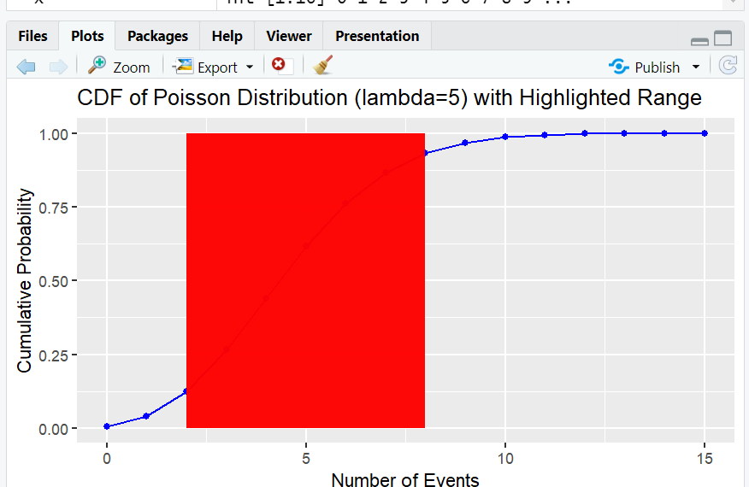

**Coding Examples**

**o PDF of Exponential Distribution**

# Install and load ggplot2 package

install.packages("ggplot2")

library(ggplot2)

# Parameter

lambda <- 0.5 # Rate parameter

# Values of x

x <- seq(0, 10, by = 0.1)

# PDF

pdf_values <- dexp(x, rate = lambda)

# Data frame for plotting

data <- data.frame(x = x, PDF = pdf_values)

# Plot PDF

ggplot(data, aes(x = x, y = PDF)) +

geom_line(color = "blue") +

ggtitle("PDF of Exponential Distribution (lambda=0.5)") +

xlab("Time") + ylab("Density")

output:

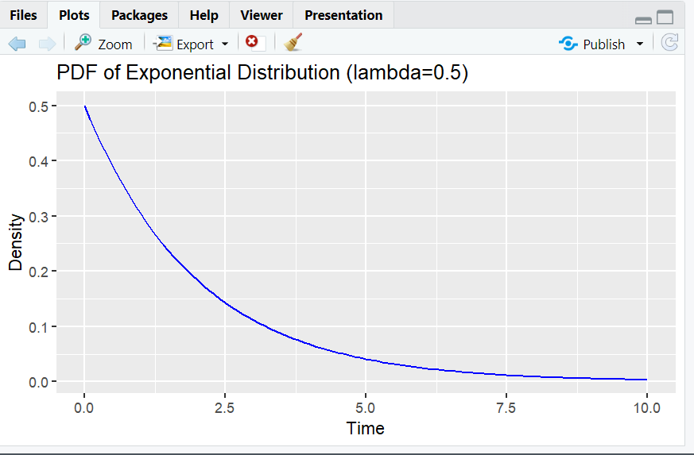

**o CDF of Exponential Distribution**

# Parameter

lambda <- 0.5 # Rate parameter

# Values of x

x <- seq(0, 10, by = 0.1)

# CDF

cdf_values <- pexp(x, rate = lambda)

# Data frame for plotting

data <- data.frame(x = x, CDF = cdf_values)

# Plot CDF

ggplot(data, aes(x = x, y = CDF)) +

geom_line(color = "green") +

ggtitle("CDF of Exponential Distribution (lambda=0.5)") +

xlab("Time") + ylab("Cumulative Probability")

output:

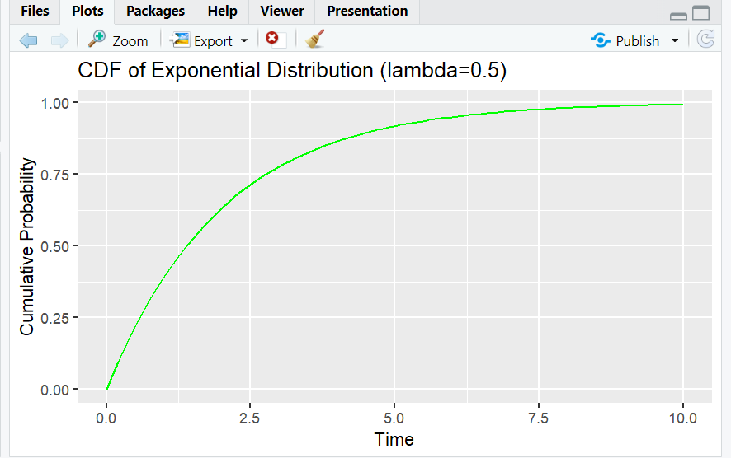

**Exercises**

1. Exercise 1: Visualize the PDF for Different Parameters

o Task: Plot the PDF of an exponential distribution with λ = 1.

o Expected Output:

# Parameter

lambda <- 1 # Rate parameter

# Values of x

x <- seq(0, 10, by = 0.1)

# PDF

pdf_values <- dexp(x, rate = lambda)

# Data frame for plotting

data <- data.frame(x = x, PDF = pdf_values)

# Plot PDF

ggplot(data, aes(x = x, y = PDF)) +

geom_line(color = "red") +

ggtitle("PDF of Exponential Distribution (lambda=1)") +

xlab("Time") + ylab("Density")

output:

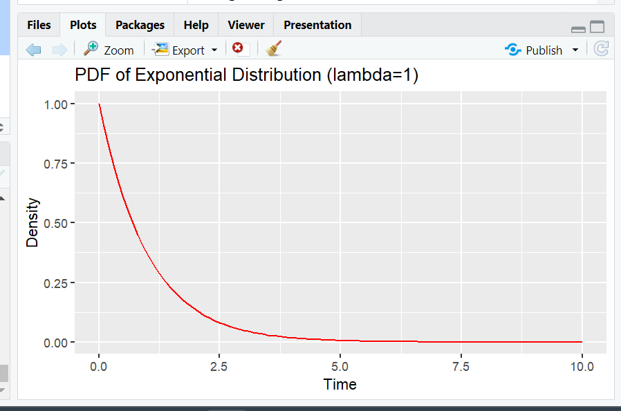

2. Exercise 2: Visualize the CDF for Different Parameters

o Task: Plot the CDF of an exponential distribution with λ = 0.2.

o Expected Output:

# Parameter

lambda <- 0.2 # Rate parameter

# Values of x

x <- seq(0, 20, by = 0.1)

# CDF

cdf_values <- pexp(x, rate = lambda)

# Data frame for plotting

data <- data.frame(x = x, CDF = cdf_values)

# Plot CDF

ggplot(data, aes(x = x, y = CDF)) +

geom_line(color = "purple") +

ggtitle("CDF of Exponential Distribution (lambda=0.2)") +

xlab("Time") + ylab("Cumulative Probability")

output:

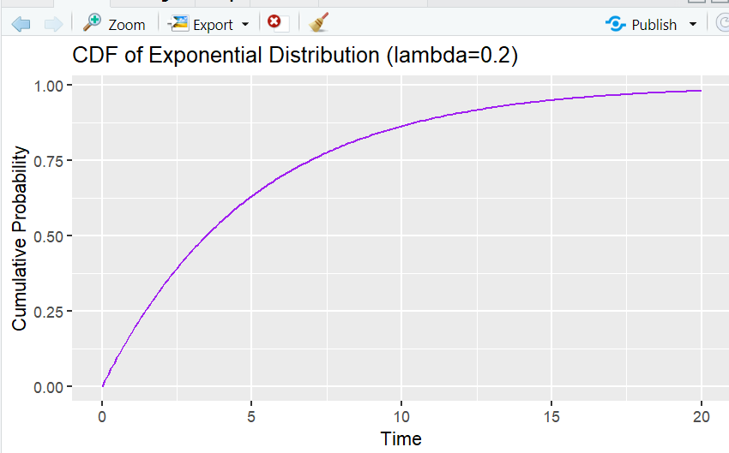

3. Exercise 3: Compare PDFs of Different Exponential Distributions

o Task: Plot the PDFs of exponential distributions with parameters λ = 0.5 and λ =

1.5 on the same graph for comparison.

o Expected Output:

# Parameters

lambda1 <- 0.5

lambda2 <- 1.5

# Values of x

x <- seq(0, 10, by = 0.1)

# PDF

pdf_values_lambda1 <- dexp(x, rate = lambda1)

pdf_values_lambda2 <- dexp(x, rate = lambda2)

# Data frame for plotting

data <- data.frame(x = rep(x, 2),

PDF = c(pdf_values_lambda1, pdf_values_lambda2),

Lambda = factor(rep(c("lambda=0.5", "lambda=1.5"), each =

length(x))))

# Plot PDFs

ggplot(data, aes(x = x, y = PDF, color = Lambda)) +

geom_line() +

ggtitle("PDFs of Exponential Distributions (lambda=0.5 and lambda=1.5)") +

xlab("Time") + ylab("Density")

output:

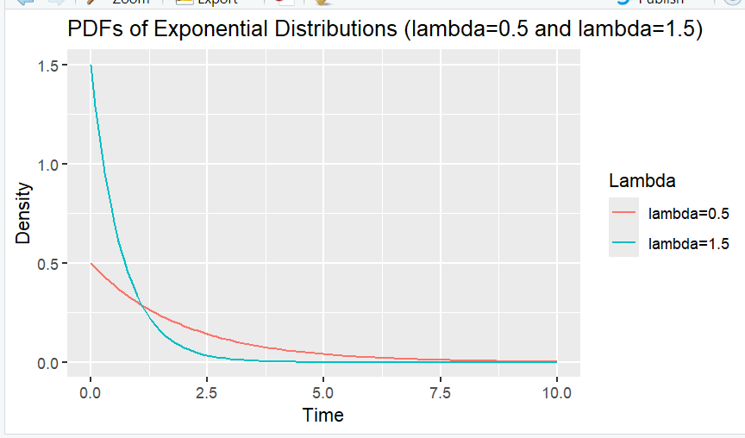

4. Exercise 4: Calculate and Plot the Probability of Time Ranges

o Task: Calculate the probability that the time between events in an exponential

distribution with λ = 0.8 falls between 2 and 5. Plot the CDF and highlight the

probability range.

o Expected Output:

# Parameter

lambda <- 0.8 # Rate parameter

# Values of x

x <- seq(0, 10, by = 0.1)

# CDF

cdf_values <- pexp(x, rate = lambda)

# Probability of time between 2 and 5

prob_range <- pexp(5, lambda) - pexp(2, lambda)

print(prob_range) # Output should be the cumulative probability

# Data frame for plotting

data <- data.frame(x = x, CDF = cdf_values)

# Plot CDF and highlight the range

ggplot(data, aes(x = x, y = CDF)) +

geom_line(color = "green") +

ggtitle("CDF of Exponential Distribution (lambda=0.8) with Highlighted

Range") +

xlab("Time") + ylab("Cumulative Probability") +

annotate("rect", xmin = 2, xmax = 5, ymin = 0, ymax = pexp(5, lambda), alpha =

0.2, fill = "red")

Output:

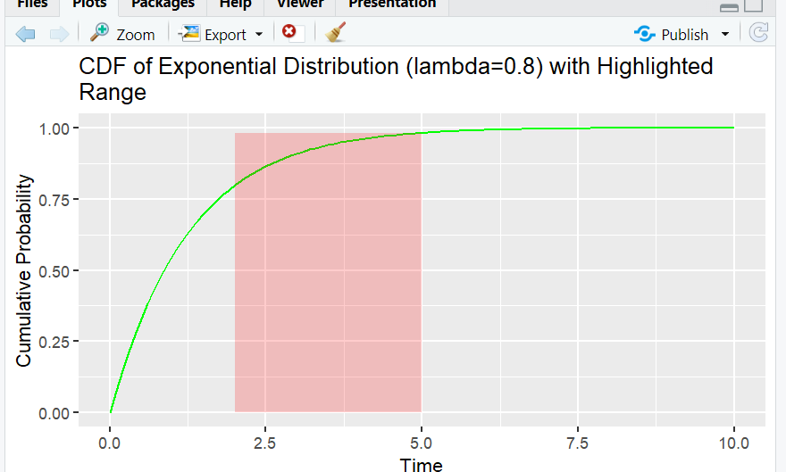

**Coding Examples**

**o PDF of Normal Distribution**

# Install and load ggplot2 package

install.packages("ggplot2")

library(ggplot2)

# Parameters

mean <- 0 # Mean

sd <- 1 # Standard deviation

# Values of x

x <- seq(-4, 4, by = 0.1)

# PDF

pdf_values <- dnorm(x, mean = mean, sd = sd)

# Data frame for plotting

data <- data.frame(x = x, PDF = pdf_values)

# Plot PDF

ggplot(data, aes(x = x, y = PDF)) +

geom_line(color = "blue") +

ggtitle("PDF of Normal Distribution (mean=0, sd=1)") +

xlab("x") + ylab("Density")

output:

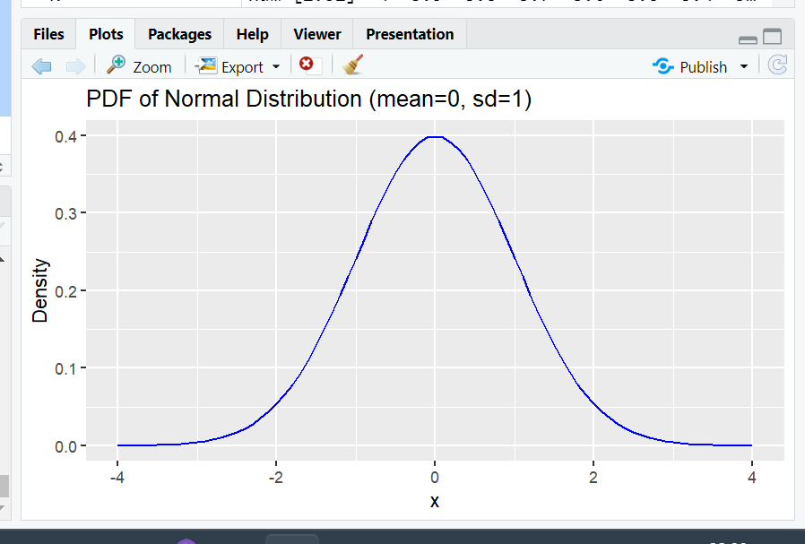

**o CDF of Normal Distribution**

# Parameters

mean <- 0 # Mean

sd <- 1 # Standard deviation

# Values of x

x <- seq(-4, 4, by = 0.1)

# CDF

cdf_values <- pnorm(x, mean = mean, sd = sd)

# Data frame for plotting

data <- data.frame(x = x, CDF = cdf_values)

# Plot CDF

ggplot(data, aes(x = x, y = CDF)) +

geom_line(color = "green") +

ggtitle("CDF of Normal Distribution (mean=0, sd=1)") +

xlab("x") + ylab("Cumulative Probability")

output:

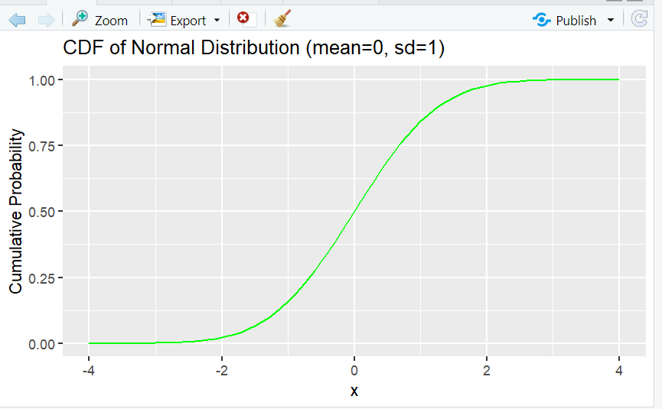

**Exercises**

1. Exercise 1: Visualize the PDF for Different Parameters

o Task: Plot the PDF of a normal distribution with μ = 2 and σ = 0.5.

o Expected Output:

# Parameters

mean <- 2 # Mean

sd <- 0.5 # Standard deviation

# Values of x

x <- seq(-2, 6, by = 0.1)

# PDF

pdf_values <- dnorm(x, mean = mean, sd = sd)

# Data frame for plotting

data <- data.frame(x = x, PDF = pdf_values)

# Plot PDF

ggplot(data, aes(x = x, y = PDF)) +

geom_line(color = "red") +

ggtitle("PDF of Normal Distribution (mean=2, sd=0.5)") +

xlab("x") + ylab("Density")

output:

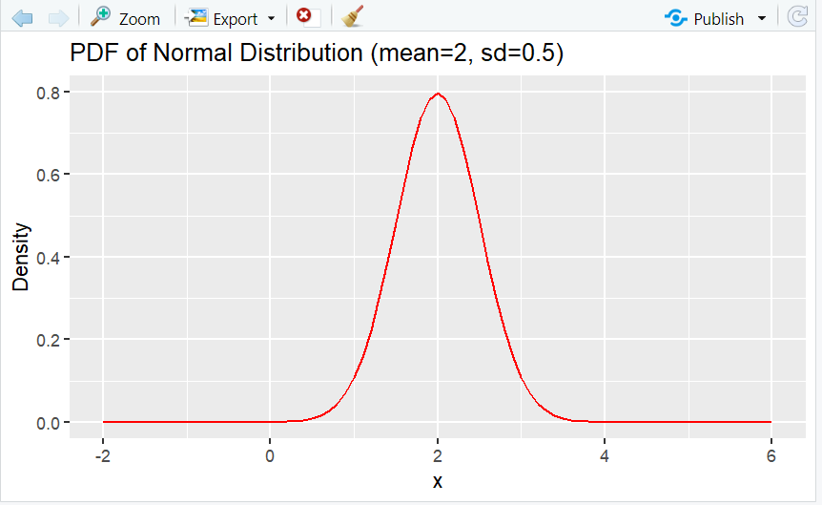

2. Exercise 2: Visualize the CDF for Different Parameters

o Task: Plot the CDF of a normal distribution with μ = -1 and σ = 2.

o Expected Output:

# Parameters

mean <- -1 # Mean

sd <- 2 # Standard deviation

# Values of x

x <- seq(-10, 8, by = 0.1)

# CDF

cdf_values <- pnorm(x, mean = mean, sd = sd)

# Data frame for plotting

data <- data.frame(x = x, CDF = cdf_values)

# Plot CDF

ggplot(data, aes(x = x, y = CDF)) +

geom_line(color = "purple") +

ggtitle("CDF of Normal Distribution (mean=-1, sd=2)") +

xlab("x") + ylab("Cumulative Probability")

output:

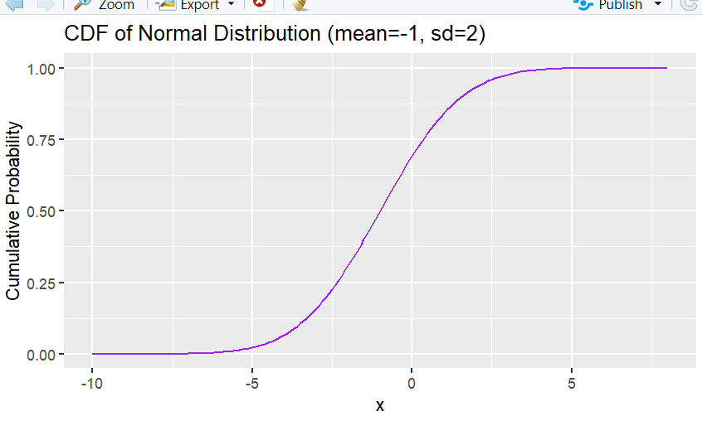

3. Exercise 3: Compare PDFs of Different Normal Distributions

o Task: Plot the PDFs of normal distributions with parameters μ = 0, σ = 1 and μ =

3, σ = 1 on the same graph for comparison.

o Expected Output:

# Parameters

mean1 <- 0

sd1 <- 1

mean2 <- 3

sd2 <- 1

# Values of x

x <- seq(-4, 8, by = 0.1)

# PDF

pdf_values_mean1 <- dnorm(x, mean = mean1, sd = sd1)

pdf_values_mean2 <- dnorm(x, mean = mean2, sd = sd2)

# Data frame for plotting

data <- data.frame(x = rep(x, 2),

PDF = c(pdf_values_mean1, pdf_values_mean2),

Distribution = factor(rep(c("mean=0, sd=1", "mean=3, sd=1"), each =

length(x))))

# Plot PDFs

ggplot(data, aes(x = x, y = PDF, color = Distribution)) +

geom_line() +

ggtitle("PDFs of Normal Distributions (mean=0, sd=1 and mean=3, sd=1)") +

xlab("x") + ylab("Density")

output:

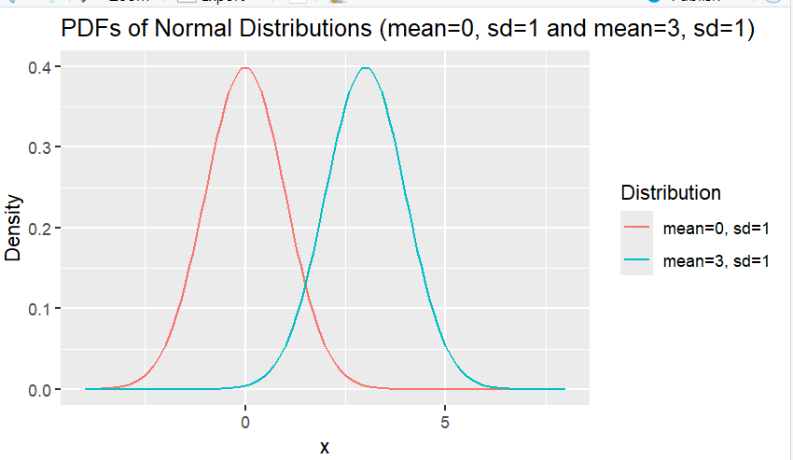

4. Exercise 4: Calculate and Plot the Probability of Ranges

o Task: Calculate the probability that a value from a normal distribution with μ = 1

and σ = 0.5 falls between 0.5 and 1.5. Plot the CDF and highlight the probability

range.

o Expected Output:

# Parameters

mean <- 1 # Mean

sd <- 0.5 # Standard deviation

# Values of x

x <- seq(-1, 3, by = 0.1)

# CDF

cdf_values <- pnorm(x, mean = mean, sd = sd)

# Probability of values between 0.5 and 1.5

prob_range <- pnorm(1.5, mean, sd) - pnorm(0.5, mean, sd)

print(prob_range) # Output should be the cumulative probability

# Data frame for plotting

data <- data.frame(x = x, CDF = cdf_values)

# Plot CDF and highlight the range

ggplot(data, aes(x = x, y = CDF)) +

geom_line(color = "green") +

ggtitle("CDF of Normal Distribution (mean=1, sd=0.5) with Highlighted

Range") +

xlab("x") + ylab("Cumulative Probability") +

annotate("rect", xmin = 0.5, xmax = 1.5, ymin = 0, ymax = pnorm(1.5, mean,

sd), alpha = 0.2, fill = "red")

output:

